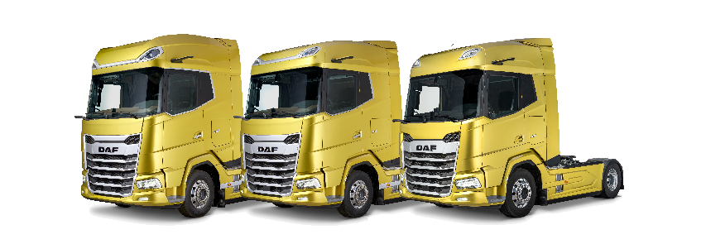
Application Form for an
Apprenticeship

PRIVATE AND CONFIDENTIAL

Leyland Trucks is an Equal Opportunities Employer. If you would like to discuss any adjustments that we can implement to assist you to complete your application, please contact us on 01772 625883 or leyland.jobs@paccar.com

Apprenticeship Applied For (choose from drop down list): Choose an item.

If you are applying for the Level 4 Apprenticeship and have a preference please select it below using the drop down list
Choose an item.

PERSONAL DETAILS

Surname Forename
Address Home Phone
Mobile
Email

Why have you applied for an Apprenticeship with Leyland Trucks?

(You may like to include in your answer why you are interested in this specific apprenticeship; details of any practical projects or experiences you have; and any ideas for your future career.)

QUALIFICATIONS
Subject Predicted or Achieved? (Please select one)

English GCSE Grade Predicted☐

Achieved ☐

Math’s GCSE Grade Predicted☐

Achieved ☐

Science GCSE Grade Predicted☐

Achieved ☐
If applicable please list any Level 3 qualifications (A-Levels/BTEC) you have achieved or are working towards. Please list Subjects and Grades including predicted grades

Please give details of positions of responsibility held (Schools or Clubs)

WORK EXPERIENCE

Please detail any work experience you have completed inc duties performed

Name and address of employer/Dates/ Position held/ Duties performed.

SUPPORTING INFORMATION
Please detail the qualities you feel you possess that make you an ideal candidate for an apprenticeship at Leyland Trucks

Please describe what you anticipate to be the most beneficial aspects of undertaking this specific apprenticeship.

Please use this section to support your application by describing any particular skills, knowledge and experience you have gained and how they will assist you in your apprenticeship. (You may wish to detail any hobbies, interests or pastimes that are relevant to the role)

Where did you hear about our apprenticeship scheme?

School Visit ☐
Career Fairs ☐
Website ☐
Facebook ☐
LinkedIn ☐
Instagram ☐
Word of mouth ☐
Other
If other please specify …………………………………………………………….
Leyland.Jobs@PACCAR.com
or

RETURN COMPLETED FORMS TO:
Amber Fitzgerald
Leyland Trucks Ltd
Croston Road,
Leyland, Lancashire
PR26 6LZ

