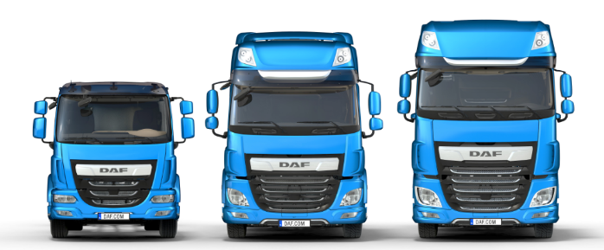

Application for employment
Material Handler role
Private and Confidential
Please complete in capitals and Black Ink

MATERIAL HANDLER
Position Applied For:
(*Delete as appropriate)

PERSONAL DETAILS

Surname Forename(s)

Address

Telephone

Mobile

Email

Email

Do you require a work permit to work in the UK? Yes No

It is unlawful to employ a person who does not have permission to work in the UK. Leyland Trucks will not be able to employ you if you cannot produce appropriate documentation when requested.

Are you willing and able to work:-
I AM OVER 18 YEARS OF AGE Yes No

OVERTIME Yes No

DAYS ONLY Yes No
(normally between 7am and 6pm)

SHIFTS Yes No
(e.g. nights, 2 shift system, double day shifts)

Leyland Trucks is an EQUAL OPPORTUNITIES EMPLOYER
.

EDUCATION AND QUALIFICATIONS

Further Education / University | From | To | Qualifications Obtained (subject and grade e.g. A-Level / Degree)
School | From | To | Qualifications Obtained (subject and grade e.g. GCSE)
Membership of Professional Bodies | From | To | Qualifications Obtained / Level of Membership
Please give details of any skills / achievements relevant to the position you are applying for
Please give details of any skills / achievements relevant to the position you are applying for (e.g. fork lift truck license, foreign language, etc)

Please complete the following section in date order beginning with your current or most recent employment. You must
WORK EXPERIENCE
explain any gaps in your employment.

Name & Address of  Employer | Position Held | Description of Duties/Responsibilities
From / /  To / / | Notice Required | Reasons for Leaving
 | Annual Salary £
Name & Address of Employer | Position Held | Description of Duties/Responsibilities
From / /  To / / | Notice Required | Reasons for Leaving
 | Annual Salary £
Name & Address of Employer | Position Held | Description of Duties/Responsibilities
From / /  To / / | Notice Required | Reasons for Leaving
 | Annual Salary £
Name & Address of Employer | Position Held | Description of Duties/Responsibilities
From / /  To / / | Notice Required | Reasons for Leaving
 | Annual Salary £
Please continue on a separate sheet if necessary

SUPPORTING INFORMATION
Please detail the qualities you feel you possess that make you an ideal candidate for Leyland Trucks:

Please detail any warehousing experience you have.

Explain your experience of working to Health & Safety standards

Explain your experience of working to Quality standards

ADDITIONAL INFORMATION

Please use this section to support your application with any additional information

Any offer of employment is subject to our receiving two references which we deem satisfactory, one of which should be from your current employer (or most recent if unemployed). Please give names, telephone numbers and occupations of two work related referees. We will only contact your current employer after obtaining your permission. In signing this application form you are giving us permission to contact any of your previous employers for reference purposes if we deem it appropriate.
REFERENCES

Name:
Position:
Address:
Phone:
Email:
Name:
Position:
Address:
Phone:
Email:

When you complete this form, you accept that employment with Leyland Trucks is subject to the following conditions:

• Satisfactory references will be required (details are required above)

• Passport or identification documents must be produced in compliance with
Home Office Legislation to confirm the Company is legally able to employ you.

• An employment medical, which includes a drugs and alcohol test, must be passed.

• Evidence of any relevant qualifications must be produced.

Declaration:

I certify that the information given on this application form including the Equal Opportunities Monitoring Form is correct.

I understand that any willful omission or falsification may lead to the disqualification of this application or disciplinary action including dismissal if appointed.

Signed Date

When you have completed this form please return to:

HR Department  Leyland Trucks Ltd  Croston Road, Leyland, Lancashire  PR26 6LZ | Or | Leyland.Jobs@PACCAR.com
HOW WE STORE AND USE YOUR DATA

All or parts of the information on this form may be stored on computer or hard copy files and used for the purpose of personnel administration, your future employment within the Company if successful, statistical and business analysis. If you are not successful for a position with the Company, your data will be stored for a period of 2 years after which it will be destroyed. Such use will be subject to the provision of the Data Protection Act 2018 and relevant subsequent legislation.

Please complete this form in order to help us monitor Equal Opportunities in Employment. This form will be kept separate from your application form, and has no part in the selection process.

Surname Forename(s) Position Applied For

Gender Monitoring

Please tick appropriate box Male Female

Age Monitoring
Date of Birth

National

/ / Insurance No.

Ethnicity Monitoring
Please check the box which best describes your ethnic / cultural / racial origin:
WHITE MIXED ASIAN BLACK CHINESE British White & Black Caribbean Indian Caribbean Chinese English White & Black African Pakistani African
Scottish White & Asian Bangladeshi Other
Welsh Other Other
Irish
Other

DISABILITY MONITORING
Do you suffer with a disability as defined by the DDA, or a long term health condition?
Yes □ No □
What is the effect or impact of your disability or health condition?

Are there any reasonable adjustments that would need to be made?
REHABILITATION OF OFFENDERS ACT 1974
Have you ever been convicted of a criminal offence (spent convictions do not need to be declared) under the
Rehabilitation of Offenders Act 1974?

Yes No

(if yes please give details)

Signed ____________________________________________________ Date __________________

